Opportunities and challenges for quantum-assisted machine learning in near-term quantum computers

This research focussed more on what we can do with the quantum machines that we have and that we are going to have in near future than to solve current problems with Quantum computers we’ll have in the next generation or maybe later

In case of interdisciplinary QML computationally expensive subroutines are outsourced to a quantum device and to analyze quantum states instead of classical data. QAML not to be confused with AQML (Applied Quantum Machine Learning) that uses ML to analyze Quantum experiments. The problems this deals with are basically for problems with statistically hard algorithms like Image and Speech recognition problems.

Reserach in this field has been focusing on tasks such as classification, regression, Gaussian Models, vector Quantization, PCA, etc.
The approach is simple- we convert classical data to Quantum readable data and send it to Quantum computers to apply ML subproblems. Once we get the solution we can use it to move further upwards but this whole idea needs a theoretical universal Quantum Machine which is not available in the real world. However we can use this idea at a smaller scale (and in fact we have used it at a smaller scale in several research papers).

A number of quantum algorithms for machine learning are based on the idea of amplitude encoding, that is, to associate the amplitudes of a quantum state with the inputs and outputs of computations. Since a state of qubits is described by complex amplitudes, this information encoding can allow for an exponentially compact representation. Intuitively, this corresponds to associating a discrete probability distribution over binary random variables with a classical vector. - Wikipedia

Amplified Encoding- To be filled

In the paper’s approach the modern Qcomputers with 100-1000 qbits won’t be able to fulfill the promises of polynomial or exponential time improvements because for that we will need a Qcomputer with millions or even billions of Qbits of processing power. The scalability and efficiency of modern Algos makes QAML less appealing.

But the author suggests 3 things that could happen to create a dent in the ML sphere -

- Focus on problems which are intractable in the ML sphere (as in problems which have more of a Brute Forcing approach than an efficient algorithmic approach to be solved and problems which can’t be optimized) for example generative models in Unsupervised and Semi Supervised learning.
- Focusing on datasets intrinsic to quantum-like correlations,making quantum computers indispensable which can be used on machines with 50-100 Qbits. Cognitive sciences problems can give us such datasets and we can use them in these domain specific problems specifically. Also can be implemented on classical datasets where Quantum like statistical correlations can be implemented
- Some classical ML algorithms have an intractable subroutine. We can use Quantum computing to develop hybrid algorithms to execute the intractable step.
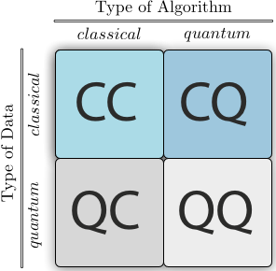

Heuristic- We have multidimensional problems and there are some problems which can only be solved by Brute forcing. In One dimensional space that is a good approach but in multi dimensional problems that simply won’t work like say Traveling Salesman problem where we have to travel to every point in the city and then return back in the shortest possible path so there is a trade off between the perfectly correct solution and the time required. We can find the solution that is near correct but that takes less time. This method is called Heuristics. But in case of heuristics we know about the underlying features of the problems.

If you don’t understand all that crap, understand heuristic something along the lines of this- something starts at a point and keeps moving in a direction. After every movement it checks itself and them continues moving. This is called Heuristics.

Metaheuristics- It is a problem independent approach which means we can use the same approach to all problems (like in Tic Tac Toe we need Alpha Beta tuning and in TSP we need a search based approach but we cannot use Alpha Beta in TSP). Here we don’t know the underlying features of the problem. It is kind of a black box problem for example- Quantum annealing, genetic algorithms (Which are used for TSP or edge weight calculation for ANNs).

Here’s how it works- It generates or finds a heuristic to find solution to an optimization problem but it makes several assumptions. The trade off between speed and correctness is met with presenting near correct solution by using less computational steps. The whole thing is in research stage as of now and experiments are still being conducted so it’ll be interesting to watch what happens over time.

For example- hill climbing approach finds the local maxima in a function. What it does is, iteratively at every point it looks at the left and right (starting from a random point) and it sets the next best point to the point that maximizes the value. So it totally depends on where the hill climbing starts. If it starts at a peak or at a ramp then it will not explore the other peaks and yield in a false positive result. We wanted to use the concept of metaheuristic to improve the efficiency of the hill climbing approach

Now in order to solve this we can use a method called Randomized Hill Climbing because it gets stuck in local maximas so whenever we get a local maxima we tell it to go and restart. The approach is to not go over the same maxima again and again and in order to do that we don’t have any undo operations in this particular approach whatsoever. (Now this is obviously a lot of reduction and the whole thing can get a little more complicated than this so we should really need to understand the whole process that goes behind it but not now.). Perturbation in the below diagram means deviation. There are so many algorithms to achieve that but we are not concerned about that for now.

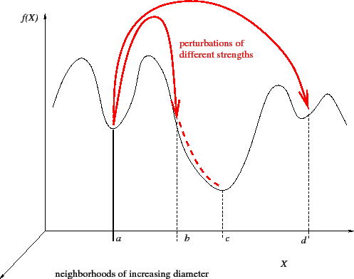

Before studying Quanum annealing we need to make this thing clear that it is not associated with simulated annealing in any manner. Annealing is the process to heat and cool a metal in order to relieve it of stress.

Quantum annealing- It is a metaheuristic to find the global minimum of a loss function over a given state of candidate solution (it can be discrete as well as continuous) using Quantum Fluctuation.

Quantum annealing starts from a quantum-mechanical superposition of all possible states (candidate states) with equal weights. Then the system evolves following the time-dependent Schrödinger equation, a natural quantum-mechanical evolution of physical systems. The amplitudes of all candidate states keep changing, realizing a quantum parallelism, according to the time-dependent strength of the transverse field, which causes quantum tunneling between states. If the rate of change of the transverse field is slow enough, the system stays close to the ground state of the instantaneous Hamiltonian, i.e., adiabatic quantum computation.[4] If the rate of change of the transverse field is accelerated, the system may leave the ground state temporarily but produce a higher likelihood of concluding in the ground state of the final problem Hamiltonian, i.e., diabatic quantum computation.[5][6] The transverse field is finally switched off, and the system is expected to have reached the ground state of the classical Ising model that corresponds to the solution to the original optimization problem. - Wikipedia

Quantum Fluctuation- According to the uncertainty principle the energy of the quantum states keeps changing. This change in energy is called Quantum fluctuation.

Quantum Parallelism- Quantum parallelism arises from the ability of a quantum memory register to exist in a superposition of base states. A quantum memory register can exist in a superposition of states, each component of this superposition may be thought of as a single argument to a function. So when some a function is performed to one component among all components in superposition, we basically perform it on all the components of the component set. Now because only n components (qbits) can hold 2^{n} states, we reduce the functional time exponentially but as the number of qbits increases it becomes increasingly difficult to find our qBits. This is the paradox of Quantum computing.

A very basic example of parallelism is something like this-

Let us say we have a function that calculates 2x mod 7 for all integers from 0 to 7 in superposition. We now calculate the whole answer at once in superposition that converts 01234567 to 012461350. Now since this is all probabilistic we see that 0 and 1 have a chance of 2/8 and all others have a chance of 1/8. So this process sounds stupid to be implemented but then we can implement it using clever algo hacks like Grover and Shor’s algorithm.

schrodinger wave- Now suppose you have a particle, you know it’s mass and you know how fast it is moving and it’s potential energy you can calculate the probability of the particle existing in a particular place. For example in this figure the calculated wave represents the amplitude of probabilistic existence. Since it is not nearly zero we can conclude that it can exist there or there are some chances that it can exist there. The function that maps this whole thing is called the Schroedinger wave function.

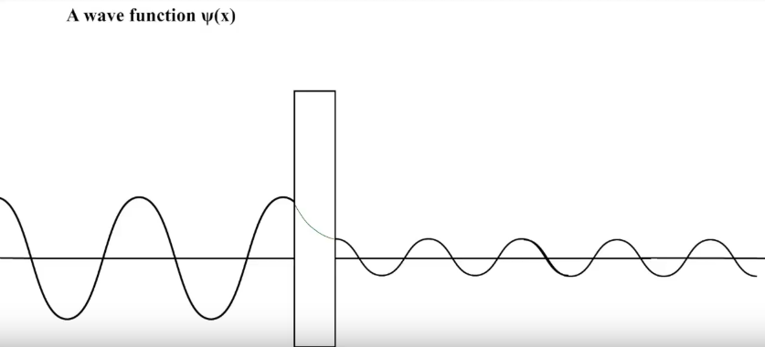

Quantum Tunneling- The probability that a qbit passes a potential barrier.

Hamiltonian- It is an operator that corresponds to the total energy of the system. It is a set that measures the total energy of the system in a spectrum and because it is closely related to time evolution of a system it is useful in Quantum computing

Adiabatic algorithms- Here is a step by step break down of what happens -

- A potentially complicated Hamiltonian is found who’s ground state can be the solution of the problem.
- A system with a simple Hamiltonian is initialized to the ground state
- Then the simple Hamiltonian is evolved in the direction of the complex Hamiltonian
- The time takes in equivalent to polynomial time computing problems for any problem

The time complexity for an adiabatic algorithm is the time taken to complete the adiabatic evolution which is dependent on the gap in the energy eigenvalues (spectral gap) of the Hamiltonian. Specifically, if the system is to be kept in the ground state, the energy gap between the ground state and the first excited state of H(t) provides an upper bound on the rate at which the Hamiltonian can be evolved at time .[7] When the spectral gap is small, the Hamiltonian has to be evolved slowly. The runtime for the entire algorithm can be bounded by:
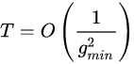

where is the minimum spectral gap for H(t). – Wikipedia
What all of that means is that

